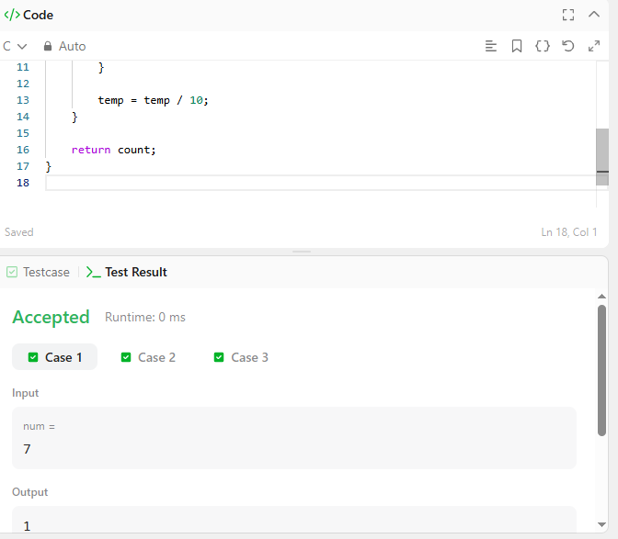

CODE –

int countDigits(int num) {
int temp = num;
int digit, count = 0;

while (temp > 0) {
digit = temp % 10;

if (num % digit == 0) {
count++;
}

temp = temp / 10;
}

return count;
}

LINK –
https://leetcode.com/problems/count-the-digits-that-divide-a-number/

